This document is a Summons ordering you to appear as a witness in a criminal case. You must appear on the day and time indicated in the subpoena

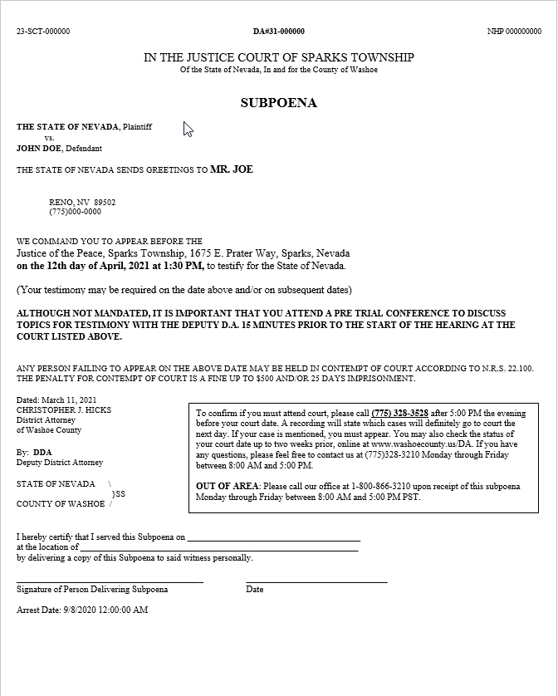
If you do not appear on the day and time indicated, you will be disobeying a court order and may be charged with Contempt, which carries a fine of up to $500.00 dollars and/or 25 days in jail

DA case number

Defendant’s name

Place and address
where the hearing will be held

Day and time
on which the hearing will be held

Date and time on which
you must appear to meet with the DDA

Warning

Deputy District’s Attorney’s name

DA’s office contact information

Arrest date

To confirm if the hearing will take place, call 775-328-3528 after 5:00 PM the evening before the date indicated on the subpoena. If the name of the defendant in your case is mentioned, you must appear at the hearing.

If you have any questions or concerns, please call 775-328-3210

